Containing Evidence of Tool Usage And Task Assignment Group 2
- Introduction
This document shows how our group used tools such as GitHub and Visual Studio Code to complete the Student Management System project. It also presents how tasks were assigned to each member.
2. Tools Used
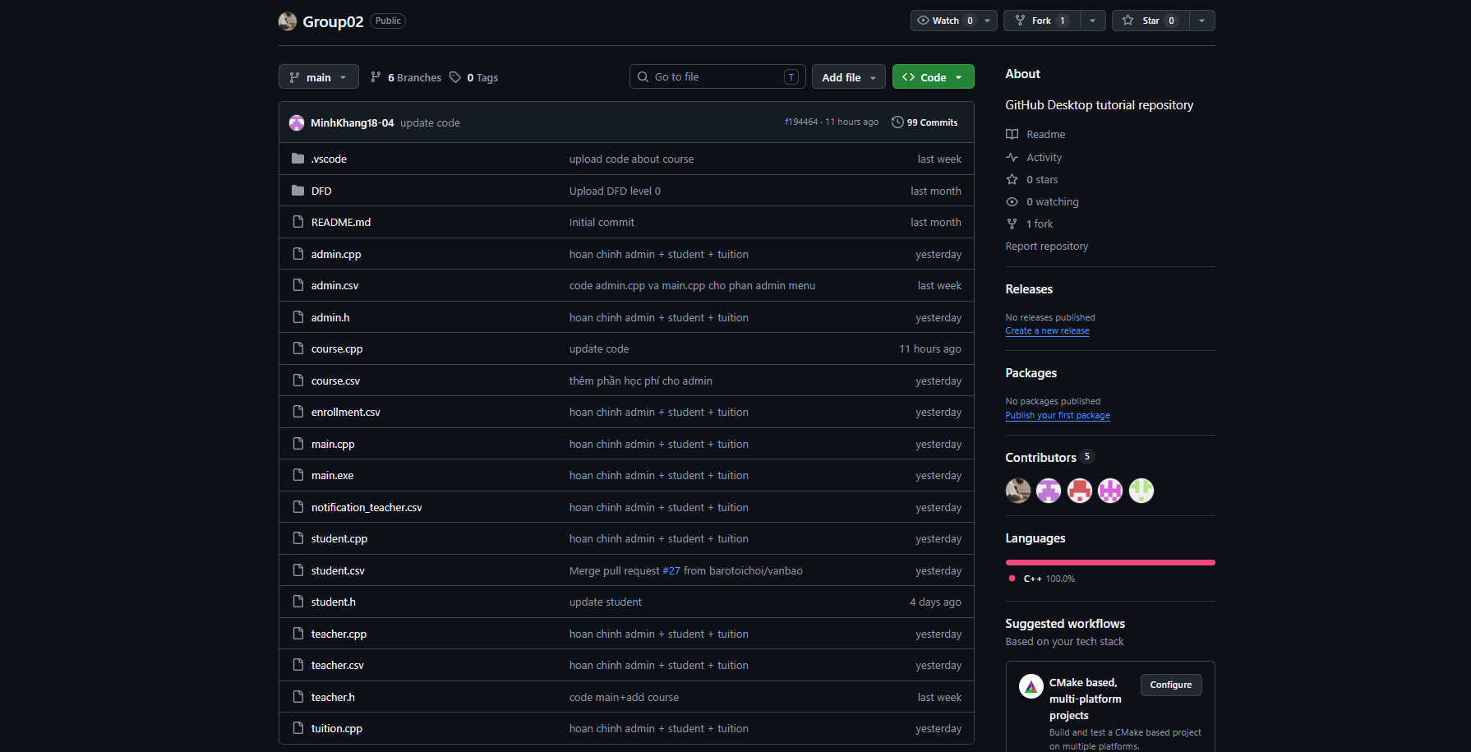
2.1 GitHub
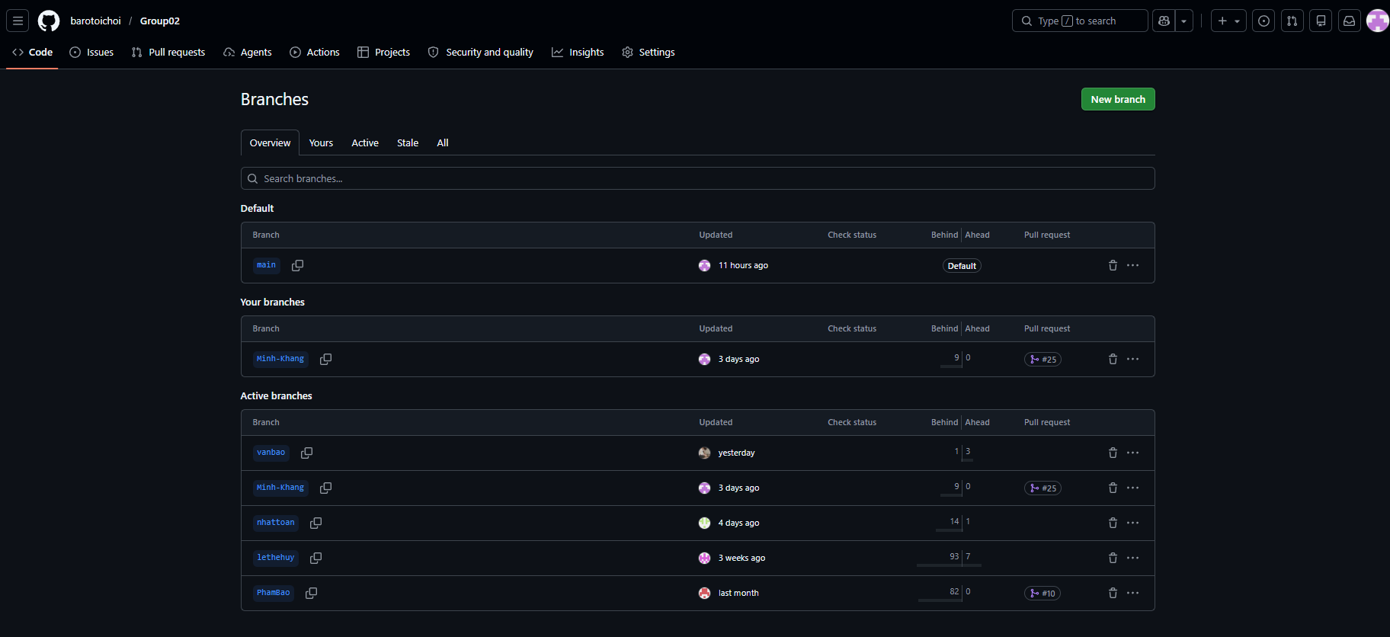
Repository (Group02)
Braches
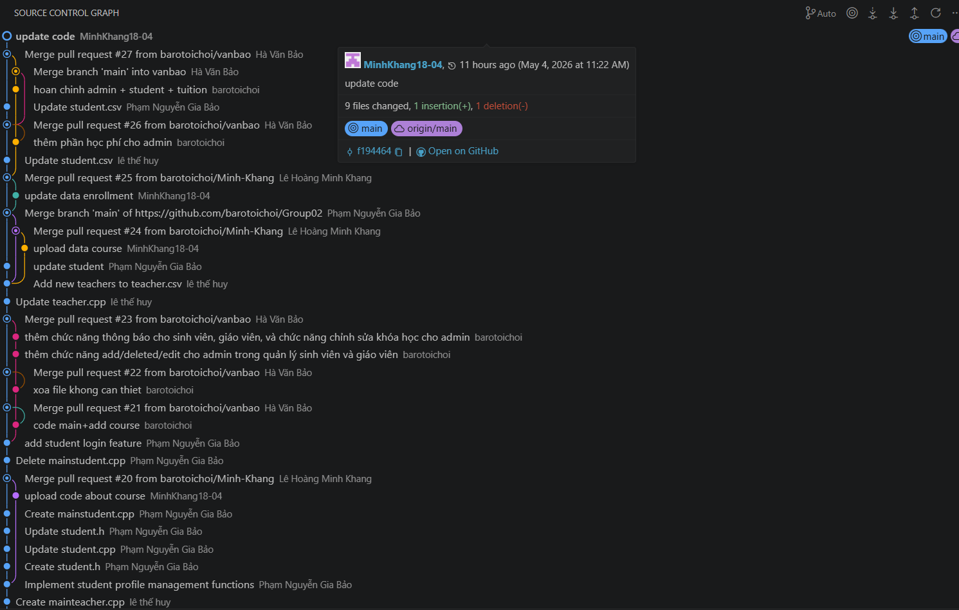
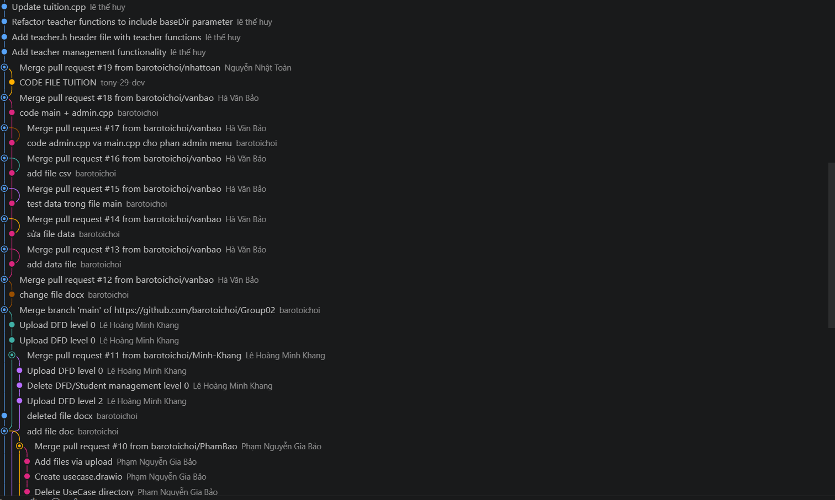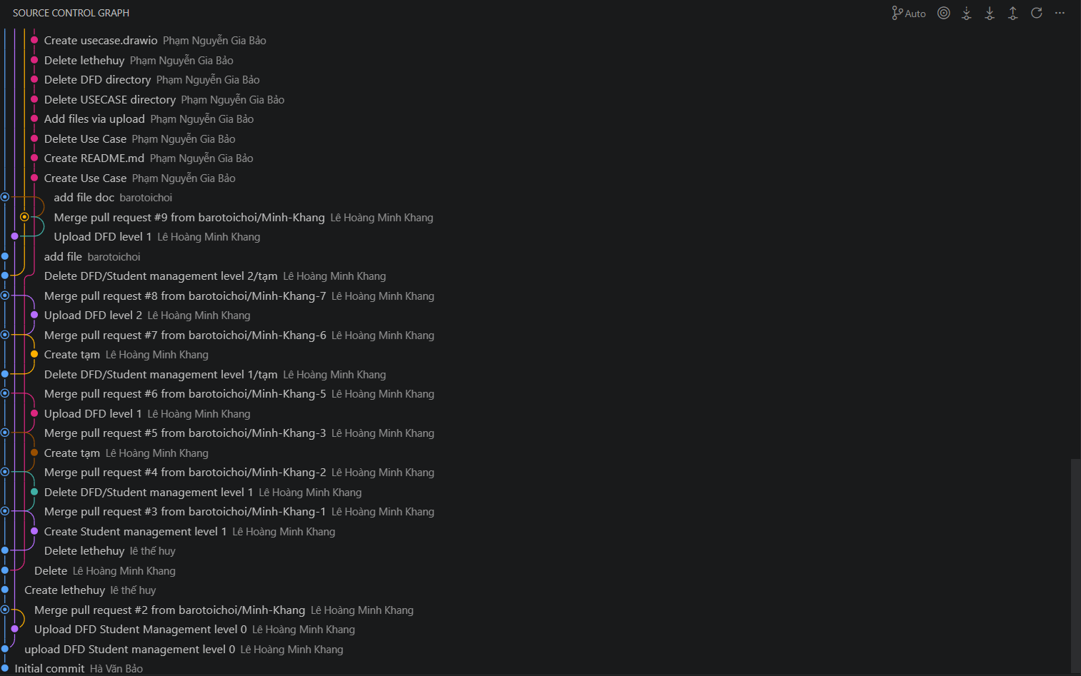
Commit history
Used for:
  - Store source code
  - Manage versions
  - Collaboration between members
2.2 Visual Studio Code
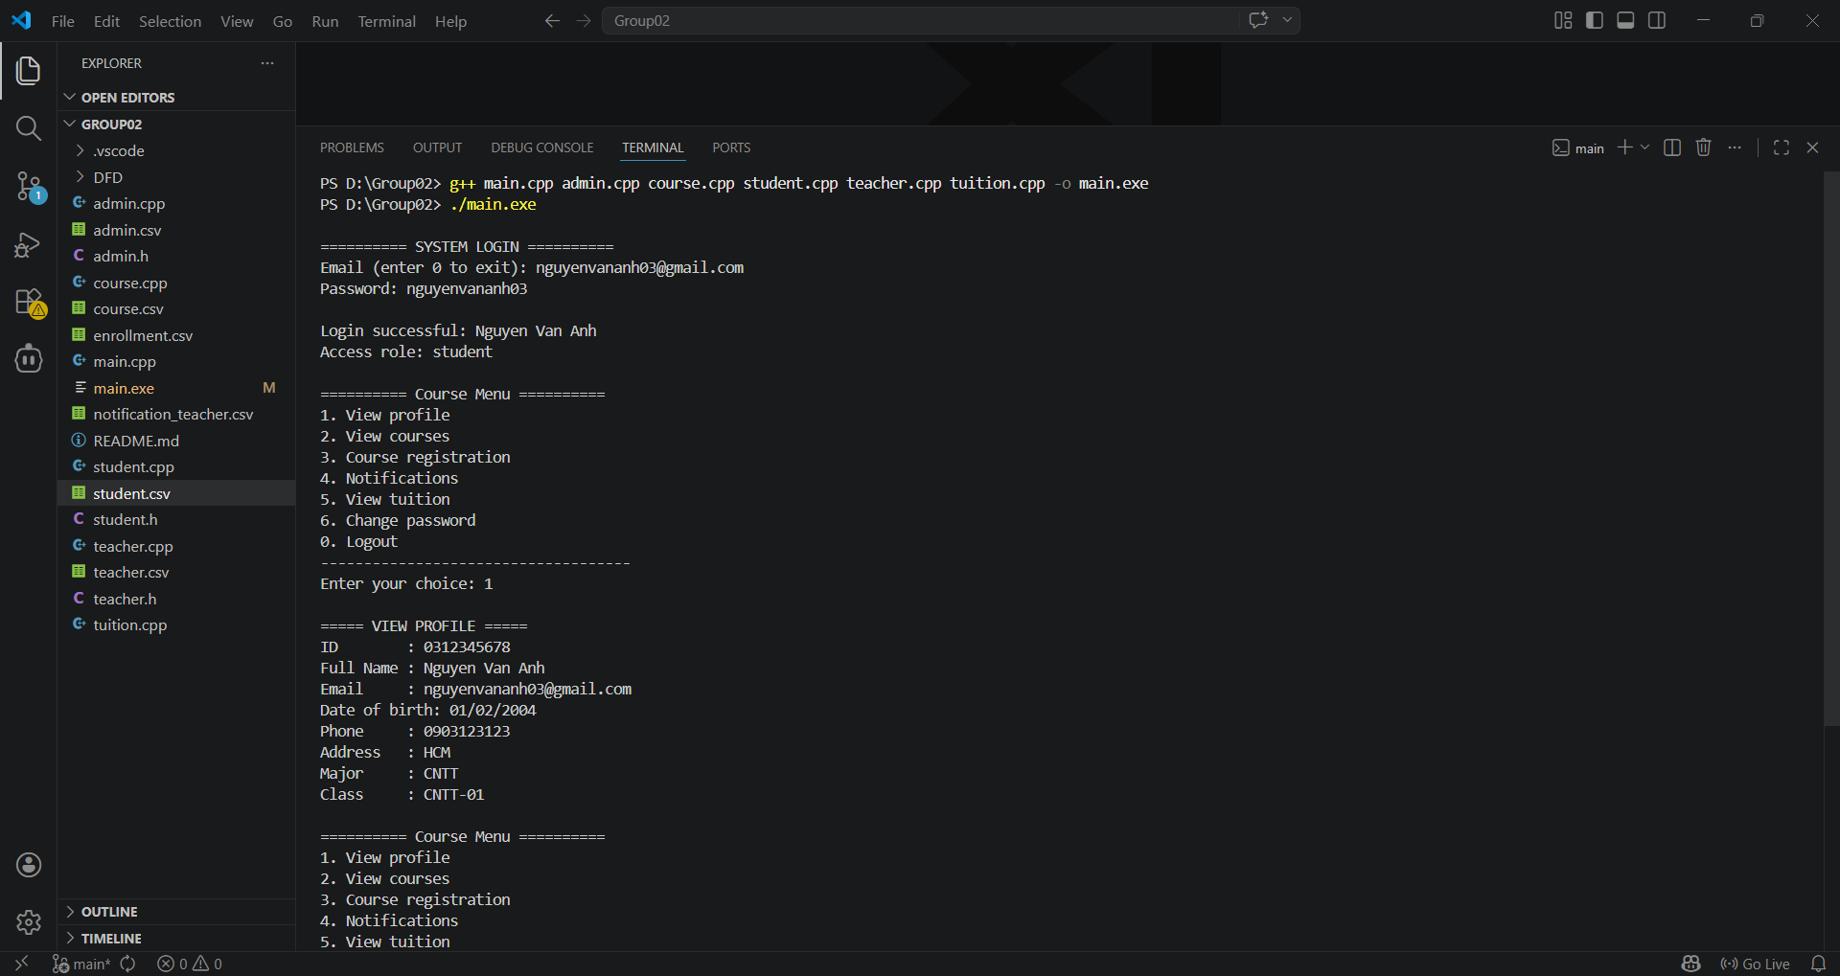
Used for:
  - Writing C++ code
  - Running and debugging program
3. Task Assignment
Full name | Student ID | Work completion level
Hà Văn Bảo | 052103014096 | 30%
Lê Hoàng Minh Khang | 082206004707 | 30%
Phạm Nguyễn Gia Bảo | 079206004263 | 13.3%
Lê Thế Huy | 083206000728 | 13.3%
Nguyễn Nhật Toàn | 079206045477 | 13.3%
4. Conclusion
In conclusion, our group successfully used GitHub and Visual Studio Code to complete the project. Task assignment helped us work effectively.

